**Biology, Castle View High School  
Dr. Jason R Mayberry**

**Study Guide: Solutions**

**Vocabulary Summary:**

1. Solution
2. Solvent
3. Solute
4. Hydrophilicp
5. Hydrophobic
6. Universal Solvent
7. Acid
8. Base
9. pH
10. Electrical Current

**Conceptual Questions:**

1. What is the relationship between a Solute, a Solvent, and a Solution.

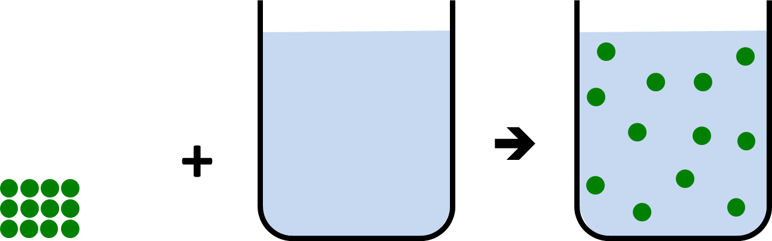

1. What properties of a substance make it Hydrophilic?
2. How can you predict from the chemical formula whether or not a substance will be hydrophilic?
3. Compare and contrast what happens when ionic substances dissolve in water and molecules with polar-covalent bonds dissolve in water – give an example of each.

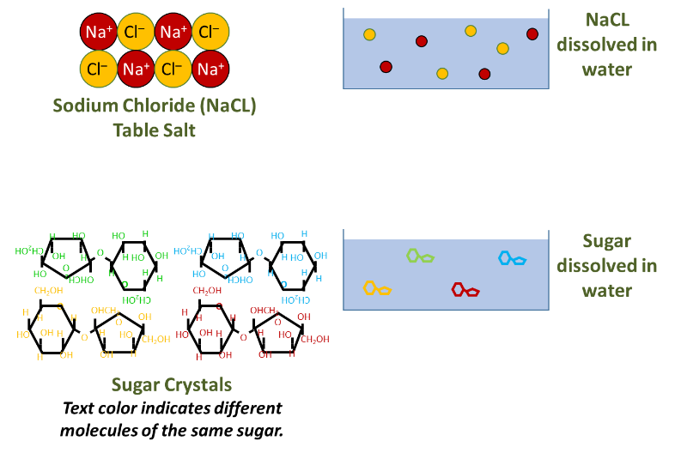

1. What properties of a substance make it Hydrophobic?
2. How can you predict from the chemical formula whether or not a substance will be Hydrophobic?
3. What does it mean for something to be acidic?
4. What does it mean for something to be basic?
5. Explain what pH is, and how it relates to acidity, and H+ ion concentration?

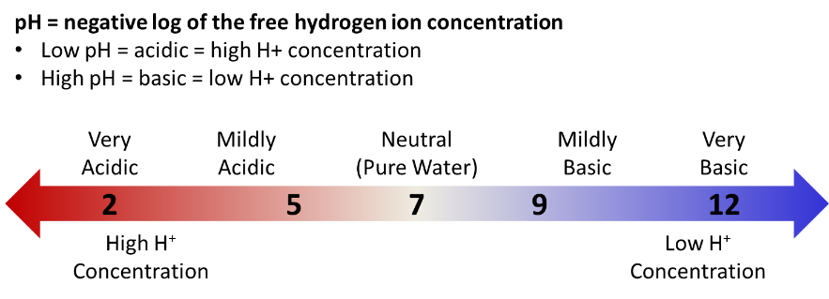

1. Why is water essential for life?
2. What is electricity?
3. How can water promote generation of an electrical current?

